Your title in 16-sized bold font

John Doe¹, Alan Smith^{1,2}
¹ Affiliation A, Postal Code, City, Country
² Affiliation A’, Postal Code, City, Country
corresponding.author@email.address

Keywords: 3-5 keywords, separated with “;”

Please summarize your research in a 1-2 pages maximum abstract, including Figures, References list, and Acknowledgements if any. Figure 1 is an example of Figure. Please use a 11-sized Georgia font for the text, which should be “Justified”.

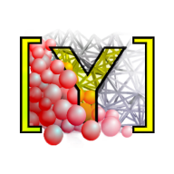
Figure 1 YADE (https://yade-dem.org/doc/), a possible DEM code

References should be quoted using the “Harvard” style, in the same manner as the following sentence, for citations directly in the text. The Discrete Element Method was first proposed by Cundall & Strack (1979).
Enclosing citations between parenthesis is obviously also possible (Cundall & Strack, 1979).

References

Cundall P.A. and Strack O. D. L. (1979) A discrete numerical model for granular assemblies, Géotechnique 29:1, 47–65
And other references by alphabetical order

Acknowledgements

Thank you for participating in this 2nd Yet Another Discrete Element Workshop !

